Disaster Plan – 2022
Resident Relocation Agreement

The following agreement is designed to assist participating organizations in the event of an area-wide disaster-initiated relocation.

All decisions to admit any person to a facility shall remain the sole right of the administrator of that facility. In the event of a disaster-initiated relocation, the organization seeking placement ("sending member") may contact any organization listed herein. It shall remain the right of the organization to which admission is sought ("receiving member") to accept or to reject, without cause, any or all potential placements.
In the event of a change of circumstances, this agreement may be renegotiated.

Thank you for your participation.

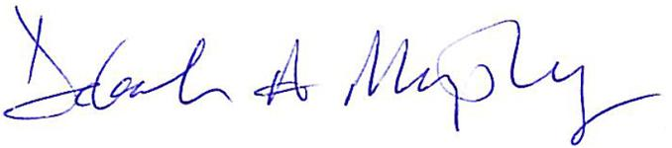

Deborah A. Murphy
President and CEO

Submit completed form to Cassi Meritt at cmeritt@leadingagewa.org

DISASTER PLAN – Resident Relocation Agreement

- Purpose - The purpose of this agreement is to establish a plan for the handling of residents in the event of an area-wide disaster.

- Limitations of This Agreement - This agreement is to be signed by participating organizations to assist each other in the event of a disaster-initiated relocation among the parties hereto. Nothing herein shall be construed as creating an enforceable right to relocate any resident. All decisions to admit any person to a community shall remain the sole right of the administrator of that community. In the event of a change of circumstances, this agreement may be renegotiated.

- Responsibilities of Participating Organizations - In the event of a disaster-initiated relocation, the organization seeking placement ("sending member") may contact any organization listed below. It shall remain the right of the organization to which admission is sought ("receiving member") to accept or to reject, without cause, any or all potential placements. Responsibilities under this agreement shall be as follows:

a) Responsibilities of the Sending Member:
- To provide as much notice as possible.
- To provide all staff necessary to meet the direct care needs of the relocated residents.
- To provide all notices of relocation to appropriate regulatory agencies, physicians, family members and other parties requiring notice.
- To assume responsibility of the care provided to residents by the sending member including, but not limited to, the providing of medications, treatments, care planning and physician supervision.
- To provide compensation to the receiving member for the care and services provided to the sending member's residents at a rate agreed to by both the sending and receiving member.
- To relocate any resident when requested by the receiving member.
- To assume liability and overall responsibility for care given to residents during the transfer and while in the receiving community.

b) Rights and Responsibilities of the Receiving Member:
- To provide temporary shelter, food, and services as agreed to prior to admission.
- To require relocation of any and all residents when, in the opinion of the receiving member, continued stay hinders their ability to meet the needs of the receiving member's residents.
- To assume joint responsibility with the sending member for the care given to residents while in the community of the receiving member.
Disaster Plan - Resident Relocation Agreement

Community Name:

Campus Name and Address:
Phone:
CEO, Administrator, Executive Director:
Person (Name/Title) to contact if implemented
Email:
Limitations on who can be admitted:
# of Relocated Persons the
Campus Can Handle:
Are you able to accommodate during heat related emergencies as a cooling station?
Resident Transportation
Resources:
Supply Transportation Resources
Comments:

We agree to participate in the Disaster Plan - Resident Relocation Agreement.
The above information is current as of this date: _______________________________

Name / Title: __________________________________________________________

Signature: ____________________________________________________________

E-mail address: _______________________________________________________

