Washington State Legislature
Legislative Building

Olympia, WA 98504-0600

May 29, 2020

The Honorable Jay Inslee
Governor
State of Washington
Legislative Building
Olympia WA 98504

Dear Governor Inslee:

We are in receipt of your letter dated May 26, 2020 requesting extension of the statutory waivers and suspensions ordered in various proclamations.

Pursuant to RCW 43.06.220(4), we hereby extend the statutory waivers and suspensions cited in the
proclamations listed below until June 17, 2020:
- 20-15.2
- 20-20.2
- 20-21.2
- 20-23.3
- 20-26.2
- 20-27.2
- 20-28.3
- 20-29.2
- 20-30.2
- 30-31.2
- 20-32.2
- 30-33.4
- 20-34.2
- 20-37.2
- 20-38.2
- 20-39.2
- 20-41.2
- 20-43.1
- 20-44.1
- 20-48.1
- 20-49.3
- 20-51.1
- 20-52.1

Senator Billig, Senator Schoesler and Speaker Jinkins support the extension of Proclamation 20-42.2 but Representative Wilcox does not. As RCW 43.06.220(4) requires the agreement of all four caucus leaders, this request for extension is denied.

Sincerely,

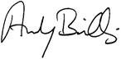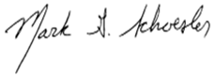

ANDY BILLIG MARK SCHOESLER
Senate Majority Leader Senate Minority Leader

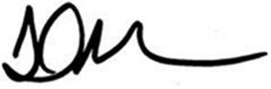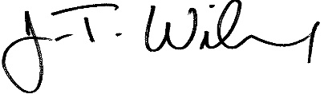
LAURIE JINKINS J.T. WILCOX
Speaker of the House House Minority Leader

