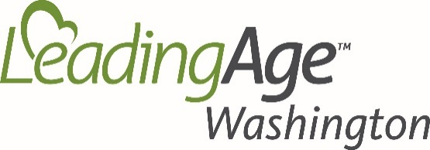
LeadingAge Washington’s 2019 Silver Star Award
Recognizing 25 Years+ of Service

Please type directly in shaded box. Save, print, fax or email!
Return by Monday - May 20, 2019

A. Person submitting this recognition

Main Contact: Title:

Organization: Email:
(for follow up questions)

B. Employee(s) our community would like recognized for 25 Years of continued service and those “Celebrating” 30, 35 or 40+ from 2018-19.

Below, please include a statement of 3-4 lines for each employee recognized, “Telling Their Story” of what they have brought to your community! LeadingAge WA awards only one 25+ Silver Star for each employee per 5 year increment. We also CELEBRATE staff that will reach 30, 35 or 40+ years of employment by June 2019. Nominees will be recognized at our Awards Luncheon during LeadingAge WA’s Annual Conference “What IF” at the Semiahmoo Resort in Blaine WA – June 11th. Let Cassi know if you have any questions or would like for her to check our records of past recipients! We appreciate your support!

Type directly in gray box. Unlimited characters
1. Employee/Title/Years/Statement:

2. Employee/Title/Years/Statement:

3. Employee/Title/Years/Statement:

4. Employee/Title/Years/Statement:

5. Employee/Title/Years/Statement:

6. Employee/Title/Years/Statement:

____________________________________________________________________________________
Email / Mail / Fax: 1102 Broadway, Suite 201, Tacoma, WA 98402
Fax: (253) 964-8876 OR Email: cmeritt@LeadingAgeWA.org

Questions? Contact * Cassi Meritt, Member Data and Services Manager
cmeritt@LeadingAgeWA.org

